NAME : PRASANT SALVI

ROLL NO : 25

SUBJECT : CLOUD COMPUTING

**Google App Engine (GAE)** is a fully managed platform-as-a-service (PaaS) provided by Google Cloud that allows developers to build, deploy, and scale web applications and services. It abstracts away much of the infrastructure management, allowing developers to focus on writing code without worrying about server provisioning, scaling, or maintenance.

**Features of App Engine:**

* **Managed Infrastructure:** App Engine handles infrastructure tasks like load balancing, scaling, monitoring, and security updates.
* **Automatic Scaling:** The platform automatically scales your application up or down based on traffic and usage patterns.
* **Supports Multiple Languages:** App Engine supports several programming languages, including Python, Java, Go, PHP, Node.js, Ruby, and .NET.
* **Integrated Services:** It easily integrates with other Google Cloud services like Cloud Datastore, Cloud SQL, and Cloud Storage.
* **Built-in Security:** App Engine provides built-in security features such as automatic HTTPS, Identity and Access Management (IAM), and denial of service protection.

**Types of App Engine:**

1. **App Engine Standard Environment:**
   * **Features:**
     + Automatically scales based on incoming traffic.
     + Provides a set of pre-configured runtime environments optimized for different languages.
     + Fast start-up times due to its use of pre-configured containers.
     + Certain limitations on available libraries, storage, and request/response timeouts.
   * **Example:**
     + A simple web application built with Python that automatically scales based on traffic. Developers write the code and deploy it on App Engine, and Google manages everything else.
   * **Use Case:**
     + Ideal for lightweight applications, rapid development, and when using the built-in services offered by Google Cloud.
2. **App Engine Flexible Environment:**
   * **Features:**
     + Customizable runtime environments, allowing developers to use any language or library by specifying custom Docker containers.
     + Supports applications that require more powerful CPUs, more memory, or longer processing times.
     + Provides greater control over the application’s environment.
   * **Example:**
     + A Node.js application using a custom Docker container with specific versions of libraries and tools that need to be used in the application.
   * **Use Case:**
     + Suitable for applications that require more flexibility in terms of runtime environment, or that need to run for extended periods.

**Diagram Representation:**

I'll describe a diagram that shows the basic architecture of Google App Engine:

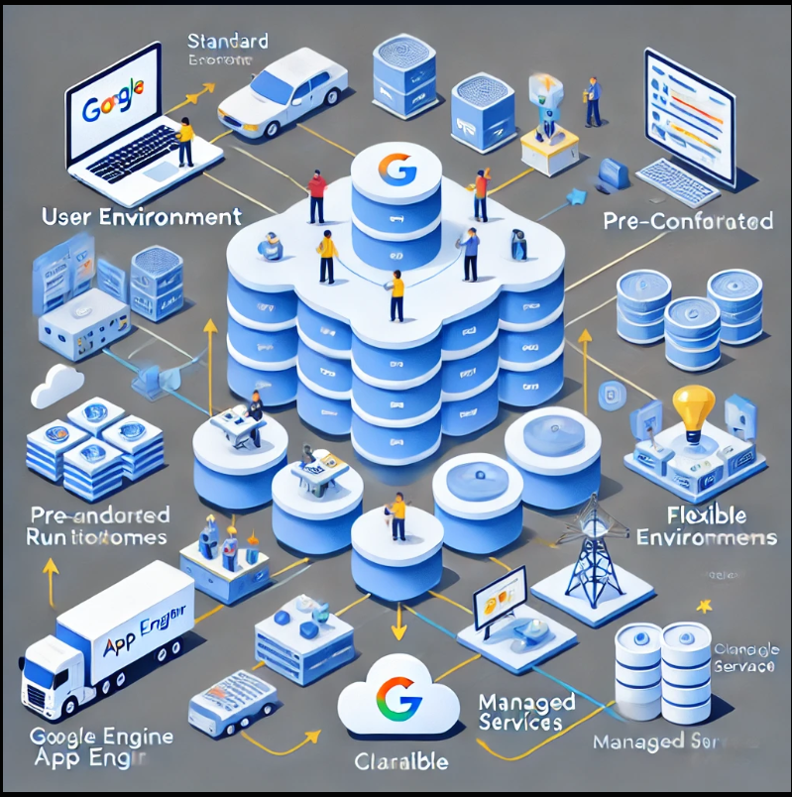

1. **User Interaction Layer:**
   * At the top, represent users interacting with the application through web browsers or mobile devices.
2. **App Engine Layer:**
   * Show two sections: one for the **Standard Environment** and another for the **Flexible Environment**.
   * **Standard Environment:** Includes pre-configured runtimes and automatic scaling.
   * **Flexible Environment:** Represents customizable Docker containers, scalable based on demand.
3. **Managed Services Layer:**
   * Beneath the App Engine layer, illustrate connections to various Google Cloud services like Cloud Datastore, Cloud SQL, and Cloud Storage.
4. **Scaling and Load Balancing:**
   * Between the User Interaction and App Engine layers, depict a load balancer that distributes incoming requests to the appropriate App Engine environment. Arrows should show how the application scales based on the number of request